**IDC4001H Douglas Muzzio**

**Shaping the Future of New York City **

# **GEOGRAPHIC/ POLITICAL HISTORY OF NYC**

**(up to 1898)**

**Census of 1890**

Census of 1890 important -- marked the end of the FRONTIER

- but also disclosed that 3 largest U.S. cities were crowding each other for 1st place:

NY

Chicago

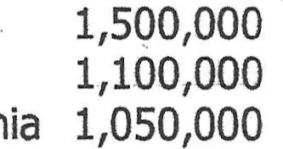Philadelphia

Chicago was coming up fast; explosive growth; 40,000 in 1850

**Consolidation**

However, 2 years before next census in 1900 a new urban phenomenon was created "Greater" New York

Consolidation of N.Y. (1,500,000), Brooklyn (840,000 in 1890), and additional communities (450,000) Long Island City, towns of Newton, Flushing, Jamaica (in present day Queens) and towns of Castleton, Middletown, Northfield, Westfield and Southfield on Staten Island

N.Y. now beat Chicago 2 to 1 (3,400,000 to 1,700,000)

NYC of now was not NYC in 1897 or 1874.

- in 1874, New York (i.e. Manhattan) absorbed the towns of Morrisania, West

Farms and Kingsbridge in what is now the Western Bronx -in 1895, New York absorbed the town of Westchester and parts of the towns of

Eastchester and Pelham in what is now the eastern Bronx Brooklyn, Brooklyn which became a city in 1834 also had been gobbling up territory 

* in 1853, Brooklyn absorbed the City of Williamsburg and the Town of Bushwick
* in 1889, the towns town of New Lots 
* in 1894, the towns of Flatbush, Gravesend, Flatlands and New Utrecht

1

